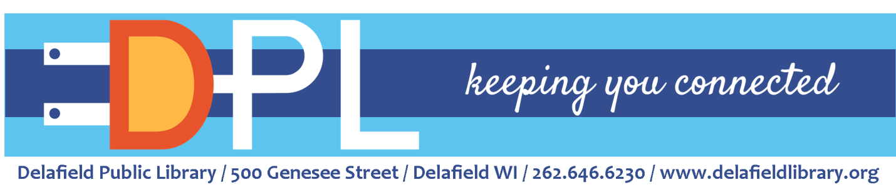
Youth Services Librarian
The Delafield Library is seeking an energetic, enthusiastic individual for the position of Youth Services Librarian. If you are a self-motivated, flexible, and forward-thinking professional with a strong public service commitment to provide great service to children, teens, and families, we welcome your application! This nearly full-time position (approx. 34 hours/week) will work diligently with and report to the Head of Youth Services Librarian.

Typical responsibilities of position:
- Provides age-appropriate children’s and teen programs and events
- Provides reference and reader’s advisory services
- Acts as a liaison to the community, organizations, schools, etc.
Major duties and responsibilities:
Children’s Focus:
- Plans and implements school age programming in coordination with the Head of Youth Services, including parts of the annual youth summer reading program. Responsible for planning and implementing two storytimes per week during most of the school year. May coordinate special events as applicable.
- Possesses extensive creativity with working with children and enjoys trying out new ideas.
- Provides outstanding internal and external customer service; demonstrates a positive attitude and supports library goals and objectives.
- Responds to patron questions and situations in accordance with library policy and in a manner to enhance the reputation of the library as a public service organization.
- Demonstrates initiative and is a self-starter; demonstrates ability to focus on details
- Assists in maintaining the department through shelf straightening, creating bulletin boards, and shelf reading.
Teen Focus:
- Plans, implements and evaluates library programs and services which fulfill the diverse educational, recreational and personal needs of local teens.
- Assumes a community engagement mindset and develops and maintains effective relationships with schools, community groups, agencies and non-profits that target youth in order to plan and deliver programs and services that meet local teen needs and interests.
- Creates an environment that attracts and invites teens to use the Library; involves teens in planning and implementing services for their age group
- Develops and maintains young adult collection using collection development practices
- Attends system level meetings as they relate to teen programming
- Ready to “hit the ground running” and make their mark on developing and sustaining a well-loved teen program

Knowledge and Abilities:
- Considerable knowledge of modern library science theory and practices
- Strong public service attitude and ability to relate to and communicate with children and young adults.
- Is eager, excited and enthusiastic to work with the teen population
- Display excellent customer service skills both with patrons in house and in community forums
- Ability to maintain and foster cooperative and courteous working relationships with the public, peers and supervisors
- Ability to perform reference work using both print and digital resources
- Demonstrates flexibility and teamwork; ability to effectively present information in one-on-one and small group situations
- Ability to work independently, organize and prioritize tasks, respond to varied/changing work demands and make decisions as required
- Ability to plan, organize and carry out a program of library service independently and/or in conjunction with head of Youth Services
- Excellent communication skills, both oral and written
- Must be proficient and comfortable with the changing nature of technology

Physical Demands of the Position:
Employee must be able to:
- Sit, stand, walk, climb, stoop, bend, twist and reach
- Lift and carry 50 pounds or less
- Handle processing, picking up and shelving books
- Push and pull objects weighing 60 to 80 pounds on wheels
- Travel to meetings outside of the library; provide own transportation to said events

Environment & Working Conditions:
- Primarily an inside work environment
- Evening and weekend hours required

Education & Experience:
- Master’s Degree in Library Science (MLIS) from an ALA-accredited college or university and/or new graduates encouraged to apply
- 2 years+ of customer service experience required
- Previous Library experience preferred

If interested, please send resume and list of three professional references to Library Director Stephanie Ramirez, sramirez@delafieldlibrary.org. Starting pay rate of $21.00/hour with excellent benefits as well as 9 paid holidays. First review of applications will begin on May 31, 2023. If you have any questions, please contact the Delafield Library at (262) 646-6230 or visit our website, www.delafieldlibrary.org.

